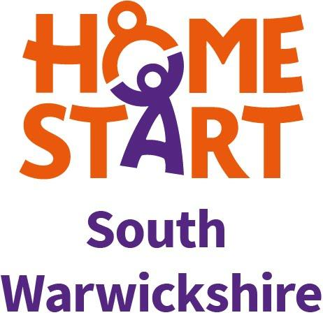

HOME-START SOUTH WARWICKSHIRE
INFORMATION FOR VOLUNTEERS

WE ARE A VOLUNTARY HOME-VISITING SCHEME in which volunteers offer confidential support, friendship and practical help to families, with at least one child of six or under, who are struggling.

Families can be referred to Home-Start by professionals working with the family, or can self-refer and are initially visited at home by one of our Family Support Managers. The volunteer then visits them once a week at home, for just a few weeks or for several months depending on the needs of the family.

BEFORE YOU BECOME A VOLUNTEER you will need to attend a Preparation Course. The course is free and covers topics such as Understanding Relationships, Listening Skills, Confidentiality, Safeguarding and Community Resources.

PEOPLE OF ALL AGES AND BACKGROUNDS are welcomed to Home-Start. No special qualifications are necessary to become a Home-Start volunteer, but volunteers are usually parents with experience of small children and family life.

DURING TRAINING you will have the chance to increase your confidence, develop your own skills, and make new friends. When you have completed the course you will receive a Certificate of Attendance.

ONCE TRAINED we would ask you to make a regular commitment of 1-2 hours a week to visit one family. Your home visits might include chatting over a cup of tea, playing with children, going for a walk or taking the family to the supermarket or a hospital appointment.

ONCE YOU START HOME VISITING you will receive regular support 1:1 and in groups from the Family Support Managers and Co-ordinators. No volunteer need ever feel that they are working in isolation.

YOU WILL BE ABLE TO CLAIM for travel expenses incurred from visiting families.

YOUR CONTACT DETAILS are kept locked and secure and certain information is entered on our database for statistical purposes in line with the General Data Protection Regulation (GDPR) (Data Protection Act 2018). All details are confidential and never passed on to third parties.

FURTHER INFORMATION can be found at www.homestartsouthwarwickshire.org.uk and www.home-start.org.uk

‘I can make a real difference to someone’s life’ – Home-Start Volunteer

E-MAIL: office@homestartsouthwarwickshire.org.uk
Tel: 07564 543806 Registered Charity No 1185280

